**Test 1:**

When was the internet born?

1. **1950s**
2. 1960s
3. 1980s
4. 1900s

**Explanation:**

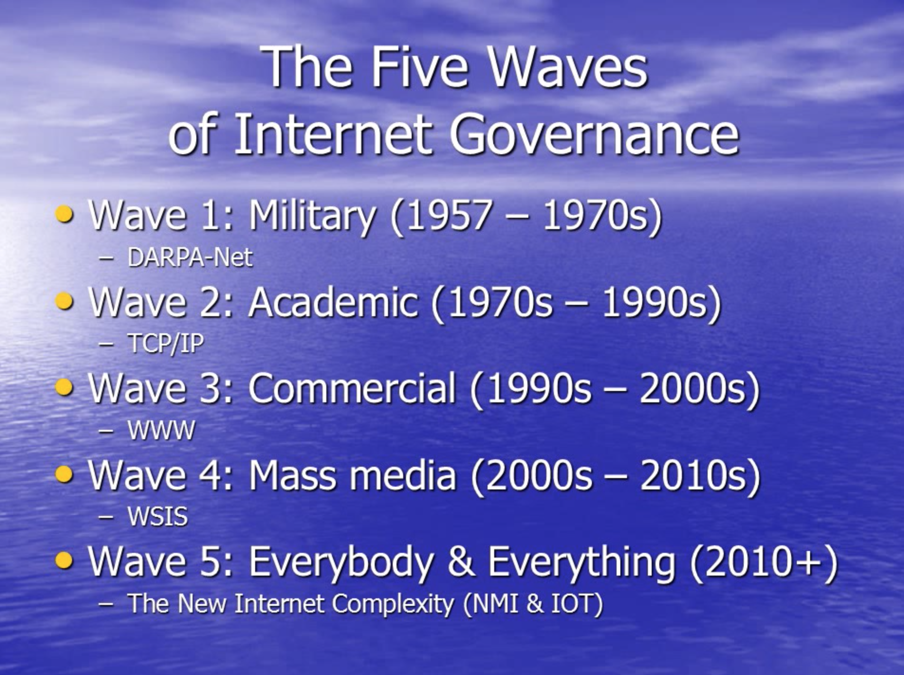

Wolfgang Kleinwächter

**Test 2**

Which was the first country to legally guarantee right to access the Internet through a universal service legislation?

A. **Estonia**

B. Germany

C. Poland

D. United States of America

**Explanation:**

Estonia was the first country to legally guarantee the right to access the Internet through a universal service legislation, in 2000. [1]

**Test 3**

Please fill the gap: According the _______ principle, every point on the network can connect to any other point on the network, without discrimination on the basis of origin, destination or type of data.

1. Right to be forgotten
2. **Net Neutrality**
3. Personal data protection
4. General Data Protection Regulation

**Explanation;**

Net Neutrality is the principle that every point on the network can connect to any other point on the network, without discrimination on the basis of origin, destination or type of data. This principle is the central reason for the success of the Internet. Net Neutrality is crucial for innovation, competition and for the free flow of information. [2]

**Test 4**

**The basic set of Internet‑related human rights does NOT include :**

1. The right to seek, receive, and impart information
2. Privacy
3. Freedom of expression online
4. **Right to be forgotten**

Explanation:

**The basic set of Internet‑related human rights includes privacy; freedom of expression; the right to seek, receive, and impart information; various rights protecting cultural, linguistic, and minority diversity; and the right to education. Other human rights come into place in the realm of digital policy please identify at least 3 of those :**

Children’s rights, online privacy, the right to access, anonymity, right to be forgotten and etc.

**Test 5**

The Internet Service Provider could not be:

1. Commercial
2. Community owned
3. Non-profit/ privately owned
4. **None of those answers**

**Test 6**

What obligations does General Data Protection Regulation bring to the companies that has EU citizen users?

1. Right to be forgotten;
2. To notify the user on the data breach;
3. Consent to retain the data;
4. Users can access request.

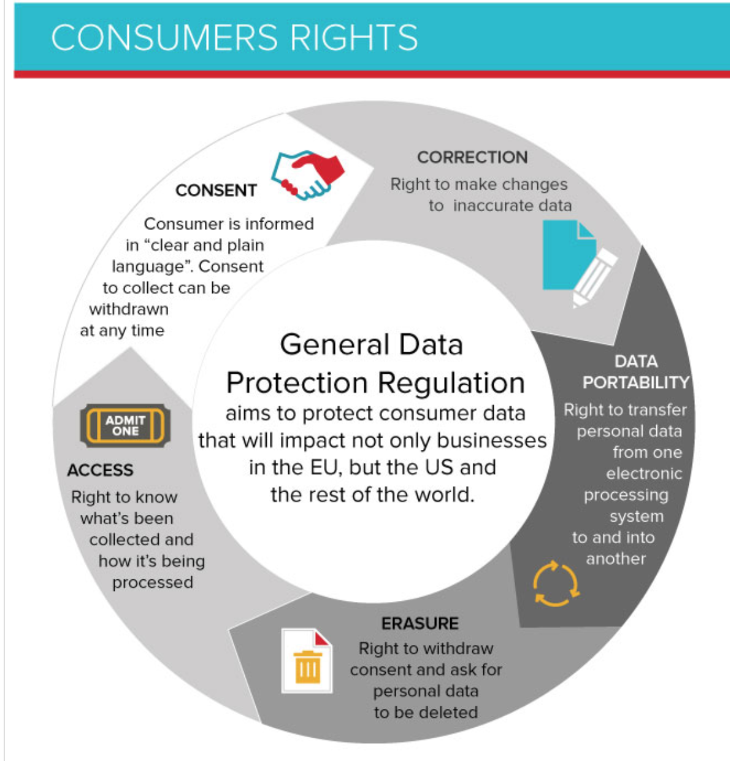

**Test 7**

What things are in the internet of things?

1. Buying stuff on the darkweb;
2. Making traditionally dumb physical devices and everyday objects smart by connecting them to the internet.
3. Artificial intelligence not involving humans;
4. Solidified wifi waves.



**Test 8**

first international treaty on crimes committed via the Internet and other computer networks, dealing particularly with [infringements of copyright](https://en.wikipedia.org/wiki/Copyright_infringement), computer-related fraud, [child pornography](https://en.wikipedia.org/wiki/Child_pornography), [hate crimes](https://en.wikipedia.org/wiki/Hate_crime), and violations of [network security](https://en.wikipedia.org/wiki/Network_security).

1. **GDPR;**
2. **Convention on cybercrime;**
3. **International covenant on internet freedom;**

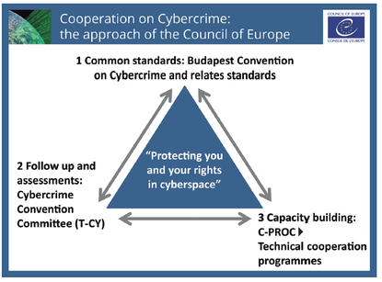

**Test 9**

[**Phishing**](https://youtu.be/BnmneAjVrM4)

**Test 10**

1. <https://www.diplomacy.edu/sites/default/files/AnIntroductiontoIG_7th%20edition.pdf>
2. https://edri.org/files/EDRi_NetNeutrality.pdf